**Sanity Checks –**

Data Cleaning Provide a meaningful treatment to all values where age is less than 18.

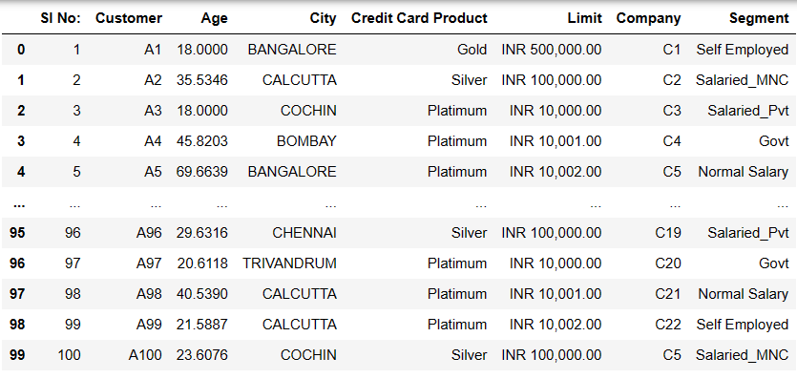

• Identity where the repayment is more than the spend then give them a credit of 2% of their surplus amount in the next month billing.

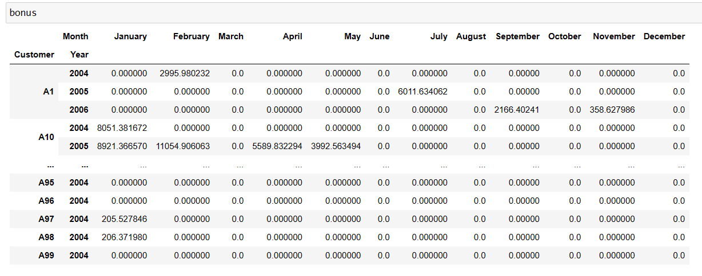

**Tasks**

->Monthly spend of each customer.

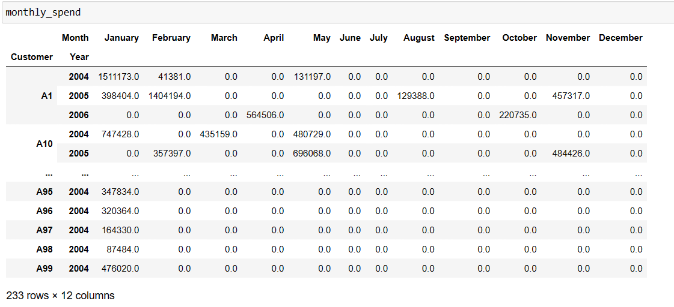

• Monthly repayment of each customer.

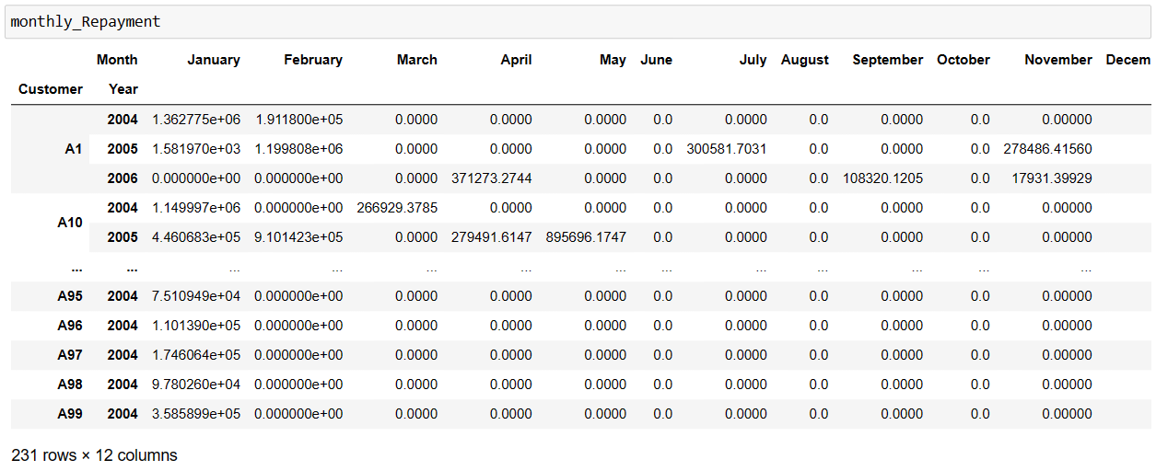

• Highest paying 10 customers.

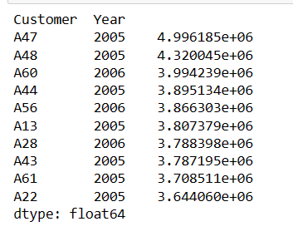

• People in which segment are spending more money.

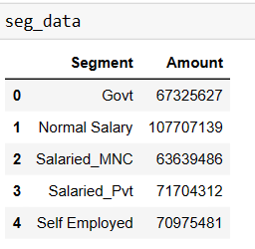

Ans-> 

• Which age group is spending more money?

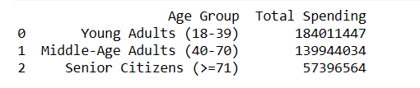

• Which is the most profitable segment?

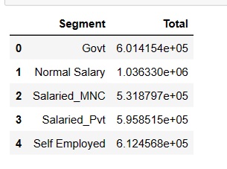

• In which category the customers are spending more money?

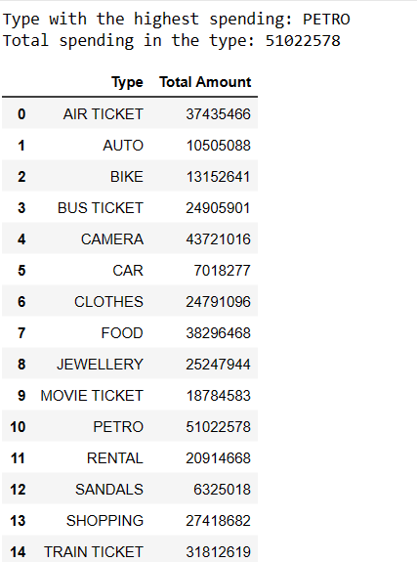

• Monthly profit for the bank.

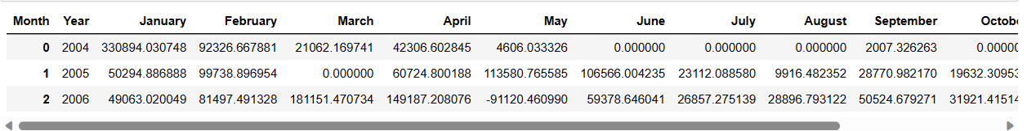

• Impose an interest rate of 2.9% for each customer for any due amount.

